# Software specifications

|  |  |  |  |  |  |  |  |
| --- | --- | --- | --- | --- | --- | --- | --- |
| Chapter number | Software required (With version) | Free/Proprietary | If proprietary, can code testing be performed using a trial version | If proprietary, then cost of the software | Download links to the software | **Hardware specifications** | OS required |
| 1-8 | Android Studio | free |  |  | <http://developer.android.com/sdk/index.html> | <http://developer.android.com/sdk/index.html#Requirements> | Windows Mac OS X Linux |
| 1-8 | Android SDK with Android 6.0 (API 23) | free |  |  |  |  | Windows Mac OS X Linux |
| 1-8 | Android device running Android 6.0 | paid | buy a device with Android 6.0 |  |  | according to phone model | Android 6.0 |
| 1-8 | Android device running Android version lower than 6.0 | paid | buy a device with Android lower than 6.0 |  |  | according to phone model | Android prior to 6.0 |
| 1-8 | Genymotion emulator | free and paid | yes | 11$ or 34$ per month | <https://www.genymotion.com/#!/store> |  | All Android versions you can create |

# Detailed installation steps (software-wise)

The steps should be listed in a way that it prepares the system environment to be able to test the codes of the book.

1. Android studio + Android sdk:
   1. download the sdk package.
      1. included:
         1. Android Studio IDE
         2. Android SDK tools
         3. Android 6.0 (Marshmallow) Platform
         4. Android 6.0 emulator system image with Google APIs
   2. Install Java Development Kit (JDK) 7:
      1. Follow instructions here: http://www.oracle.com/technetwork/java/javase/downloads/jdk7-downloads-1880260.html
   3. install sdk package
   4. Run Android studio for updates.
   5. Install Extras from Android SDK manager
2. Genymotion:
   1. Download Genymotion here: https://www.genymotion.com/#!/download
   2. Install VirtualBox (If using OSX,Windows comes with installer)   
      here: https://www.virtualbox.org/wiki/Downloads
   3. Install Genymotion
   4. System requirements :
      1. Mac OS X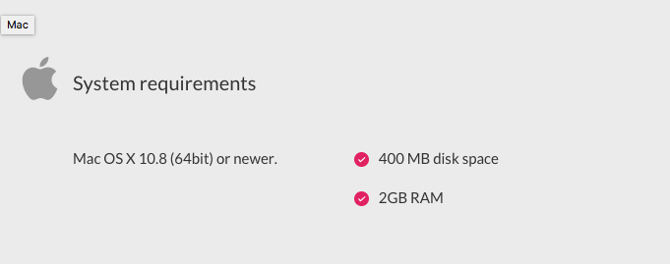
      2. Windows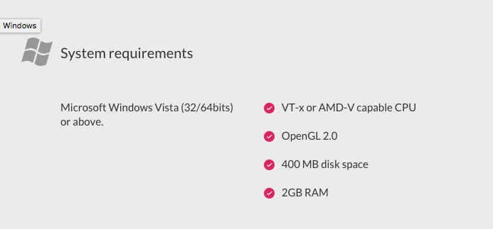
      3. Linux  
         